

**Team Name:** InnoMed

**Team Leader:** Shahid Mulani

**Problem Statement:** Develop a healthcare platform linking doctors, pharmacies, hospitals and patients (also from rural areas) for enhanced medical accessibility.

**Domain:** Health Care

**Track:** Novice

**Describe your solution:**

* Transparency in data:

Data will never be shared with any other third party. For safe and user-friendly advertisement, data will only be shared with the permission of user.

* Data Security Breach:

By encrypting sensitive data, securing data backups and avoids storing unnecessary data.

* Inability to find doctors:

User can find doctor when he/she moves from one place to another by accessing the location.

* Exploitation of user data:

Only symptom and their Disease/Meds records are to be shared with doctor’s community which consist the genuine doctors.

* Medical Registration and License:

Doctors and hospitals that are on the platform should have their Registration/license checked and approved up-to date.

* Misleading/Inaccurate information:

The patient data should be taken with high precision and accuracy in order to prevent misinterpretation and other cause.

* If the patient is not satisfied with the doctor or his treatments:

If the patient is not satisfied with doctor, he/she can apply for a better doctor on the platform without any repetitive explanation and extra fees.

**Technology Stack:**

* Frontend: HTML, CSS, JavaScript, Figma, Bootstrap.
* Backend: Node.js, ExpressJs.
* Database: MongoDB.

**Innovativeness:**

* Personalized Healthcare Navigation.
* Recording of New Case. (this one can help us avoid any further pandemic, like Covid-19)
* Ethical & Legal Framework.
* Health information resource at free of cost.
* Managing appointment schedules and health record.
* Quick accessibility to local as well as online doctors.

**Show Stoppers:**

* Data Privacy and Security:
  1. HIPPA Compliance Act (HIPAA)
  2. Medical licensing
  3. Misleading/Inaccurate information
  4. Data security breach
  5. Scalability issues
  6. Privacy Concerns
* Functionality concerns:
  1. Inability to find Doctors
  2. Misinterpretation of Past Medical Records
  3. If the patient is not satisfied with the doctor or his treatments.
* Ethical concerns:
  1. Exploiting user data resources raise issue.
  2. Lack of Transparency
  3. Creating False hope

**Prototype:**

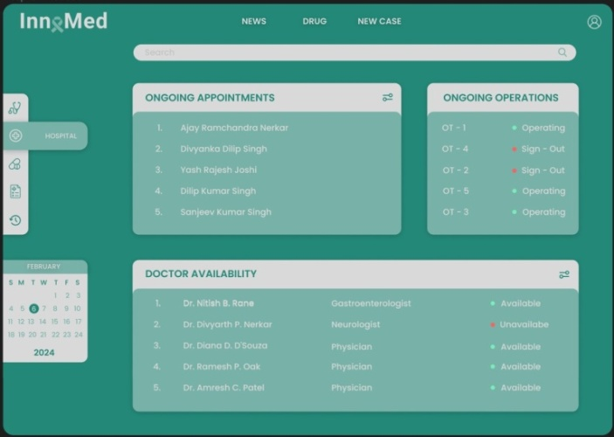Sign In/Sign Up PagePatient Interface

|  |  |
| --- | --- |
| C:\Users\Dell\Downloads\WhatsApp Image 2024-03-02 at 8.51.07 PM.jpeg | C:\Users\Dell\Downloads\WhatsApp Image 2024-03-02 at 1.31.58 PM.jpeg |
| Doctor Interface  C:\Users\Dell\Downloads\WhatsApp Image 2024-03-02 at 1.31.58 PM (1).jpeg | Hospital Interface |

**Use Case Diagram/Flow Diagram:**

